CULTURAL SPACES
CAPITAL SUPPORT FUND

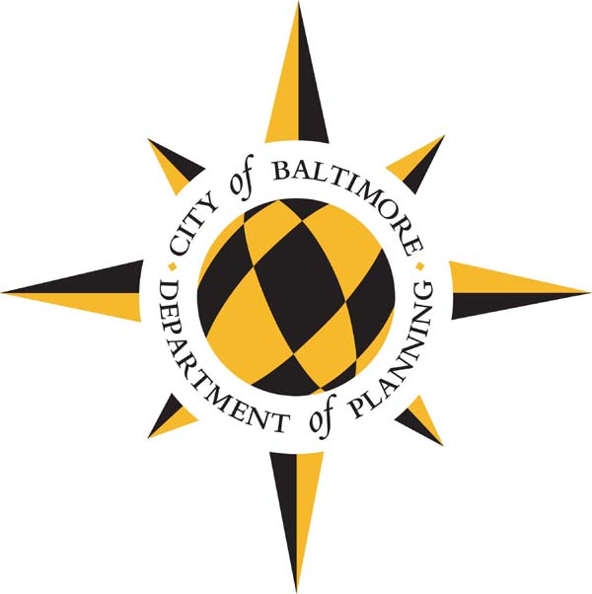

FY2024 and FY2025 FUNDING GUIDELINES & APPLICATION

Release Date: June 13, 2022
Response Deadline: August 15, 2022

Responses are to be submitted electronically:

Send application in Microsoft Word to:
Sara.paranilam@baltimorecity.gov and
Kristen.ahearn@baltimorecity.gov

PLEASE READ THESE GUIDELINES CAREFULLY BEFORE COMPLETING YOUR APPLICATION.

Important Dates 2
Overview 3
Administrative Information 6
Application Questions…………….…………………………………………………………………7

IMPORTANT DATES

Grant Application Available | June 13, 2022
Information Session | June 24, 2022  10:00am
SUBMISSION DEADLINE | August 15, 2022
Notification of Awards | October 14, 2022 (awards are contingent on approval of FY24 and FY25 capital budget)

OVERVIEW

The City of Baltimore provides limited support to cultural organizations each year through the capital budget. Every two years, organizations can apply for General Obligation (GO) bonds for eligible capital improvements to their facilities.
Funds are intended:
- to provide capital support for organizations that promote arts and culture in Baltimore City and contribute to the City’s unique identity, ensuring opportunities to experience arts and culture

In previous years, funds have supported:
- improvements to building systems, such as elevators and roofs
- improvements to public access, particularly for those with limited mobility
- building expansions or renovations

In FY2024 and FY2025, there is a total of $1 million per year available to support capital improvements at cultural institutions in Baltimore. Individual awards will not exceed $200,000 over two years. Typical awards will be between $50,000-$100,000 over a two-year period. Please note that FY24 funds will not be available until July 1, 2023 and FY25 funds will not be available until July 1, 2024. If awarded, funds are provided on a reimbursement basis and expenses cannot be incurred until after final approval of the budget by City Council.

Eligible Applicants
Applicants must meet all of the requirements below:
- The process is open to museums, galleries, and theaters, as well as all arts or cultural venues within designated arts and entertainment districts (click here for a map of these districts or visit the Maryland State Arts Council website to search by address).
- Any organization that wishes to apply must be a registered non-profit in good standing with the State Department of Assessment and Taxation.
- Organizations must have a physical location in Baltimore City.
- Must own the facility or have a minimum of a fifteen-year lease with responsibility for capital improvements.
- The facility must be open to the general public.

Eligible Projects
Funding can be used to fund a variety of capital projects. Eligible capital projects, as defined by Board of Estimates policy, are any physical betterment or improvement and any preliminary studies and surveys relative thereto, including, but not limited to, any property of a permanent nature, and equipment needed in connection with such improvement, when first erected or acquired. Projects should have a minimum 15-year service life.
Examples of projects funded in the past include upgrades to a plaza or entrance to accommodate customers with limited mobility, roof replacements, building envelope upgrades, elevator replacements, or museum/exhibit expansions.
Ineligible Uses of Grant Funds
- Projects or improvements costing less than $50,000
- Vehicular equipment
- Repair or maintenance items costing less than $100,000 or which are of an emergency nature
- Salaries other than those which are properly capitalized as part of the project cost
- Operating Support
- Relocation
- Repayment of existing loans or liens
- Projects that support specific religious or other affiliations, and/or that support political actions, causes, advocacy, or parties

Review Criteria
The Department of Planning uses similar criteria as the Planning Commission’s Capital Improvement Program to evaluate projects:
- Legal Mandate
- Equity. According to the City’s equity assessment program, equity means closing the gaps in policy, practice and allocation of resources so that race, gender, religion, sexual orientation and income do not predict one’s success, while also improving outcomes for all.
- Health and Safety
- Asset Condition
- Return on Investment
- Environmental Impact
- Efficiency and Effectiveness

The City may give additional consideration to projects that address the following:
- Project provides improvements to City owned assets
- Project provides access for Baltimore City Public School students
  - Project enables organizations to build financial and organizational capacity

The City may also consider the organization’s capacity to execute the project and timely expenditure of previous allocations.

ADMINISTRATIVE INFORMATION

Information Session
The Department of Planning will host a virtual information session on June 24, 2022 at 10:00 am. The Information Session will be held via WebEx. A link is available on the City’s Cultural Spaces Capital Support website. If special accommodations are required, please email Kristen Ahearn at kristen.ahearn@baltimorecity.gov at least three business days in advance.

Award Amounts
Final awards are made by the Director of Planning and must also be approved in the FY24 and FY25 capital budgets, which means there is a long lead time to receive these funds. The Department of Planning reserves the right to make an award of funds in an amount other than what is requested in the Grant Application.

Incurring Expenses

The City of Baltimore is not responsible for any cost incurred by any applicant in preparing and submitting this application or requested supplemental information in response to this application.

Compliance with Law

By submitting an application, organizations awarded funds agree that they will comply with all Federal, State and City laws, rules, and regulations and ordinances applicable to its activities and obligations under this program.

Public Information Act Notice

The Department of Planning commits to handling all information regarding financial assets in strictest confidence. Applicants should give specific attention to identifying any portions of their application that they deem to be confidential, proprietary or trade secrets and provide justification why such material should not be disclosed under the Maryland Public Information Act SS 1-601 et seq. of the State Government Article, Annotated Code of Maryland upon request by the public.

APPLICATION QUESTIONS

General Information
Name of Institution:
Contact Person:
Contact Title:
Contact Phone:
Contact Email:
Date:

Project Information
Project Name:
Project Location:
Short project description: (limit 225 characters)
Total FY24&25 G.O. Bond Request:

Capital Cost Estimate (use whole dollars)
Design:
Site Acquisition:
Site Preparation:
Construction:
Equipment:
Inspection:
Contingency:
Other:
TOTAL:

Project Fund Sources (use whole dollars)
 | Previous Appropriations | FY 2024 | FY 2025 | Future Funds | TOTAL
City Loan Request:
Other City Funds:
State:
Federal:
Private:
Other (Specify): Facility rental earned revenue
TOTAL:

Please provide specific information for any State, Federal, Private, or Other fund sources for the project. If City funding other than G.O. Bonds is involved, please specify. Include names of specific grant or agency budget programs, amounts committed, fiscal years of commitments, etc. Please include specific information for private fundraising campaigns including overall goal, amount committed to date, and timeline for campaign completion. Submit copies of commitment documents for all fund sources if available.

Proposed Project Schedule:
Study | Start: |  | Complete:
Design | Start: |  | Complete:
Advertise for Bids: | Start: |  | Complete:
Award Contract: | Start: |  | Complete:
Construction: | Start: |  | Complete:

Project Narrative

- Provide a detailed description of the project and how it enhances or improves your facility, including the public experience of your facility. You may submit any supporting materials that describe your project such as design/concept drawings, and scope of work.

- Provide a detailed explanation of the public benefit, expected outcomes from the project, and implications if the project is not funded.

- Please check which Planning Commission capital project review criteria apply and explain how your request meet the criteria:
- Legal Mandate
- Equity
- Health and Safety
- Asset Condition
- Return on Investment
- Environmental Impact
- Efficiency and Effectiveness

Facility Information
- Are you applying for a capital improvement to a City-owned building?
- Are you applying for a capital improvement to a historic building? If the property is City owned or meets the criteria of landmark designation or contributing to a local historic district it will be reviewed by CHAP.

Financial Information
- Please provide financial statements and audits, if available, for the past three years.

- If you have previously received allocations of Baltimore City General Obligation Bonds, please describe how they were used and how the improvements impacted the organization.

- If you have previously received allocations of Baltimore City General Obligation Bonds that are currently unspent, please explain.

Population Served
- Please describe the population that visits and/or utilizes the subject facility, including any quantitative measures you may have of past attendance or participation (race, gender, age, zip code, etc.).

- Do you anticipate the proposed capital improvement will alter the make-up of the population that visits your site or utilizes your organization’s programs? If so, please describe.

- Does the organization have a focus on African American leadership, experiences and/or visitors or other historically disinvested communities and/or populations in Baltimore City? If so, please describe.

- What programs, if any, does the facility provide for Baltimore City Public School students? How many students participate annually and are there fees associated with student participation?

Other Information

13. Explain how your organization will oversee this project. Describe your organization’s capacity to successfully manage this project, including partners that you will work and their respective roles.

14. If there is any other pertinent information pertaining to this request not already covered by this application, please briefly describe below.

